
YEAR: 7
SUBJECT: SCIENCE
MARKING KEY

TEST: Moon and Tides

TIME: 50 minutes

QUESTIONS: Part A: Multiple Choice Questions (12 marks)
Part B: Short Answer Questions (27 marks)

TOTAL MARKS: 39 marks

SECTION ONE: Multiple Choice Questions (1 mark each)
Answer this section on the separate multiple choice answer sheet

1. What force keeps the planets (including Earth) orbiting the Sun?

- Air pressure
- The Sun’s gravity
- Buoyancy
- The angle of the Earth on its axis

2. What is gravity?

- It lets us float because every object is made up of matter
- The non-contact force that pulls objects to the centre of the Earth
- The contact force that pushes objects to the centre of the Earth
- Is an example of a frictional force because it attracts objects to the centre of the Earth

3. What two forces act on all falling objects in the Earth’s atmosphere?

- Buoyancy and gravity
- Gravity and surface tension
- Gravity and air resistance
- Buoyancy and air resistance

4. What is the weight on Earth of a person with a mass of 60 kilograms?

- 60 kg
- 600 N
- 60 km
- 500 m³

5. Mars rover was built on Earth and has been sent to Mars to send back information about the terrain. The Mars Rover has a mass of 185kg. The gravitational pull on Mars is 3.711 m/s², Earth has a gravitational pull of 9.8m/s². Select the statement which is most correct.
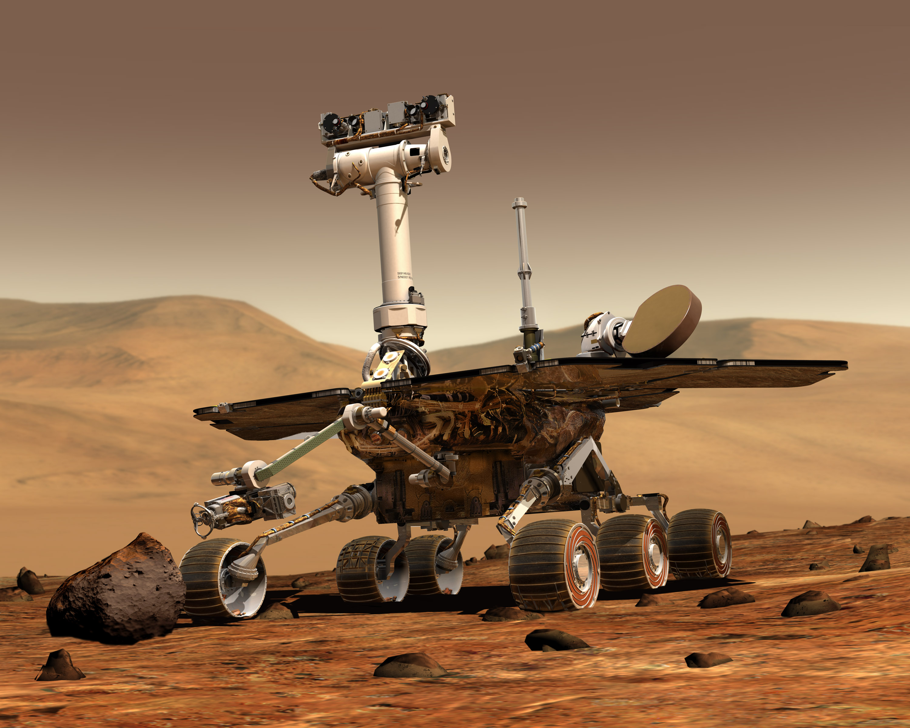
This Photo by Unknown Author is licensed under CC BY-SA

- The Mars rover will have a heavier weight on Mars.
- The Mars rover will be lighter weight on Mars.
- The weight of the Mars rover will remain constant.
- There is not enough information to determine if the weight will be affected.

6. What makes objects have different gravitational forces?
- Mass
- Weight
- Friction
- Magnetism

7. What causes tidal movements?

- The gravity of the water in the ocean is constantly changing
- The Moon’s gravitational pull causes oceans to move away from it
- The Moon’s gravitational pull causes oceans to bulge out towards it
- The Earth’s gravitational pull causes oceans to bulge out towards the Moon

8. The different shapes of the Moon as seen from Earth are called

- Crescents
- Phases
- Quarters
- Fractions

9. The main cause of day and night is:

- Rotation of the Earth
- Revolution of the Earth
- Orbit of the Earth
- The tilt of the Earth on its axis

10. Which of the following is not a Noongar Season.

- Birak
- Djeran
- Makuru
- Kaya

11. Select from the options below the most accurate definition for equinox

- The middle of summer
- The middle of winter
- Day on which night and say last for an equal amount
- Day where the most sunlight is experienced

12. Which of the following diagrams best shows the relative positions of Earth, the Moon
and the Sun during a lunar eclipse?
C

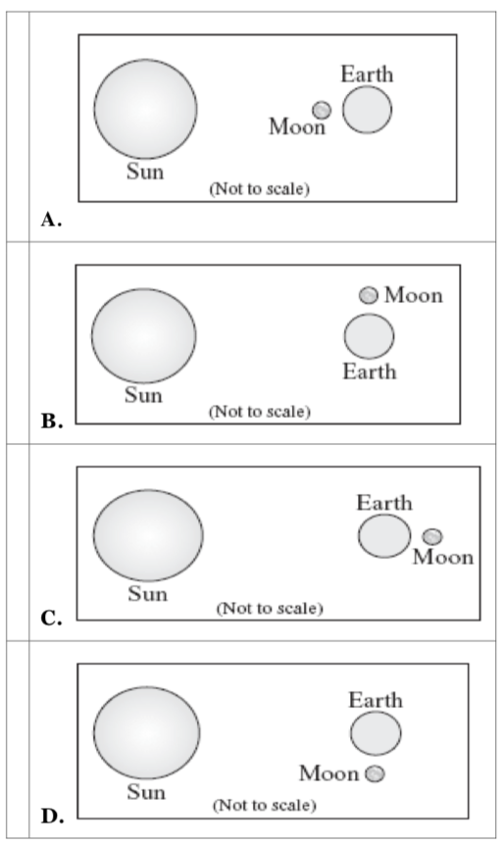


SEMESTER ONE 2021
Moon and Tides:
ANSWER BOOKLET
NAME:
FORM: DATE:
Multiple Choice Short Answer Total

/39
/35

/27

/12

/12

SECTION ONE: Multiple choice answers
Cross (X) through the correct answer.

1 | a | b | c | d
2 | a | b | c | d
3 | a | b | c | d
4 | a | b | c | d
5 | a | b | c | d
6 | a | b | c | d
7 | a | b | c | d
8 | a | b | c | d
9 | a | b | c | d
10 | a | b | c | d
11 | a | b | c | d
12 | a | b | c | d

I CAN STATEMENT | QUESTIONS
MUST  Describes how the positions of the Earth, sun and moon affect phenomena on Earth. | 1, 2, 5, 7, 8, 9, 10, 11, 13, 14, 17a, 18, 19
SHOULD  Explains how the positions of the Earth, sun and moon affect phenomena on Earth. | 3, 6, 12, 15a, 15b, 17b
COULD  Explains how the positions of the Earth, sun and moon can be used to predict phenomena on Earth. | 4. 15c, 16

SECTION TWO: Short Answer (27 marks)
Answer the questions in the spaces provided.

Question 13
Use the terms from the following list to complete the sentences below. (4 marks)
half Earth Sun sunlight far between differently reflects
The Moon doesn’t create its own light. We only see the Moon from Earth because the Moon reflects light from the Sun. One half of the Moon is always illuminated. A full Moon occurs when the Moon is on the far side of the Earth and the full light of the Sun reflects to Earth. A new Moon occurs when the Moon is between the Sun and the Earth, we can’t see any of the sunlight that is hitting the Moon. The Northern and Southern Hemispheres see the Moon’s phases differently.
½ mar each

Question 14
Write the definition of the following words: (3 marks)
Winter solstice
The shortest day of the year (1).
______________________________________________________________________________________________________________________________________________________
Solar eclipse
A solar eclipse occurs when the Moon passes between the Sun and the Earth (1).
______________________________________________________________________________________________________________________________________________________
Seasons
A season is a reasonable regular weather pattern (1).
______________________________________________________________________________________________________________________________________________________
Question 15
- Sketch the shape of (3 marks)
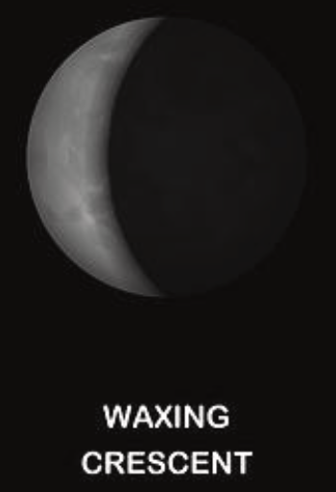
(i) A waxing crescent moon (1)

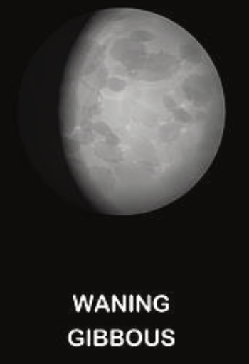
- A waning gibbous moon (1)

- A full moon (1)
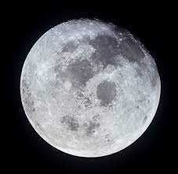

- Explain why we see various moon shapes or phases? (2 marks)
At certain times, we can see both the sunlit portion (1) and the shadowed portion of the Moon from Earth (1).
____________________________________________________________________________________________________________________________________________________________________________________________________________________________________________________________________________________________________________

- Explain how the Northern and Southern Hemispheres see the Moon’s phases differently.
Northern hemisphere – the sunlit part of the Moon travels from right to left (1)
Southern hemisphere – the sunlit part of the Moon travels from left to right (1)
(2 marks)
____________________________________________________________________________________________________________________________________________________________________________________________________________________________________________________________________________________________________________

Question 16
Explain how the Moon is responsible for producing tidal movements in Earth’s oceans.
Tides occur as a result of the gravitational pull by the Moon on the oceans (1).
The gravitational pull causes Earth and its water to bulge out on the side closest to the Moon
(1) and the side farthest from the Moon (1).
(3 marks)
________________________________________________________________________________________________________________________________________________________________________________________________________________________________________________________________________________________________________________________________________________________________________________________________________________________________________________________________________________________________________________________________________________________________________________________________________________________

Question 17
- Describe why a person would weigh more on Earth than on Moon. (2 marks)
Gravitational pull on Earth is larger (1) meaning pulling force holding someone on Earth is larger (1).

_________________________________________________________________________________________________________________________________________________________________________________________________________________________________

- The apple has a mass of 200 grams (0.20 kg). Using the formula for weight calculate the weight of the apple on Earth and the moon. (Hint: make sure to include the correct units for weight in your answer) (2 marks)

Weight = mass x gravitational pull
= m x g
Celestial Object | Mass (kg) | Gravitational Pull  (m/s²) | Weight
Moon | 0.20 | 1.62 | 0.324 N
Earth | 0.20 | 9.8 | 1.96 N

1 mark for each correct value. If they do not include units minus half mark from entire question.
Question 18
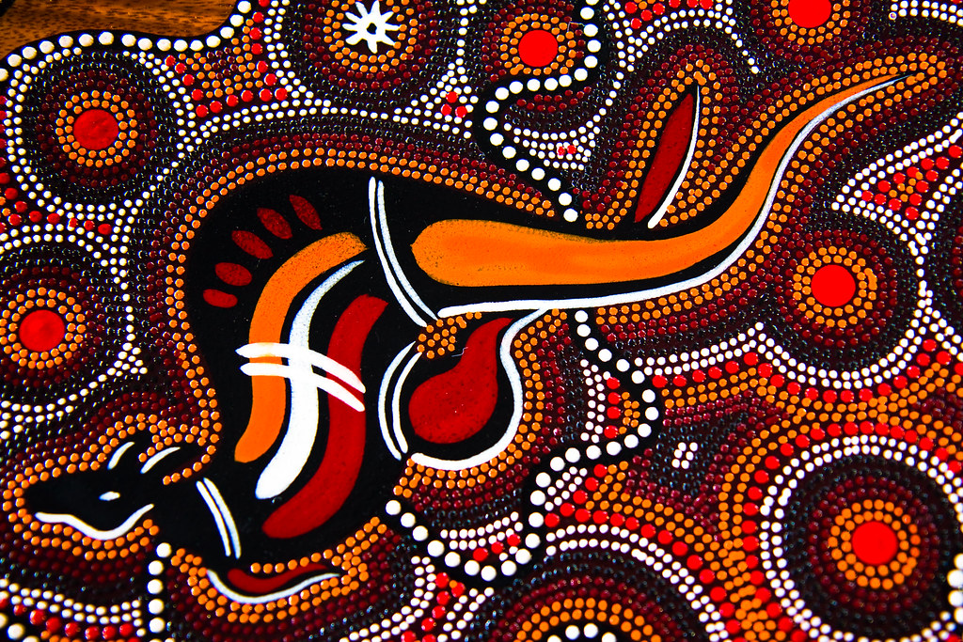
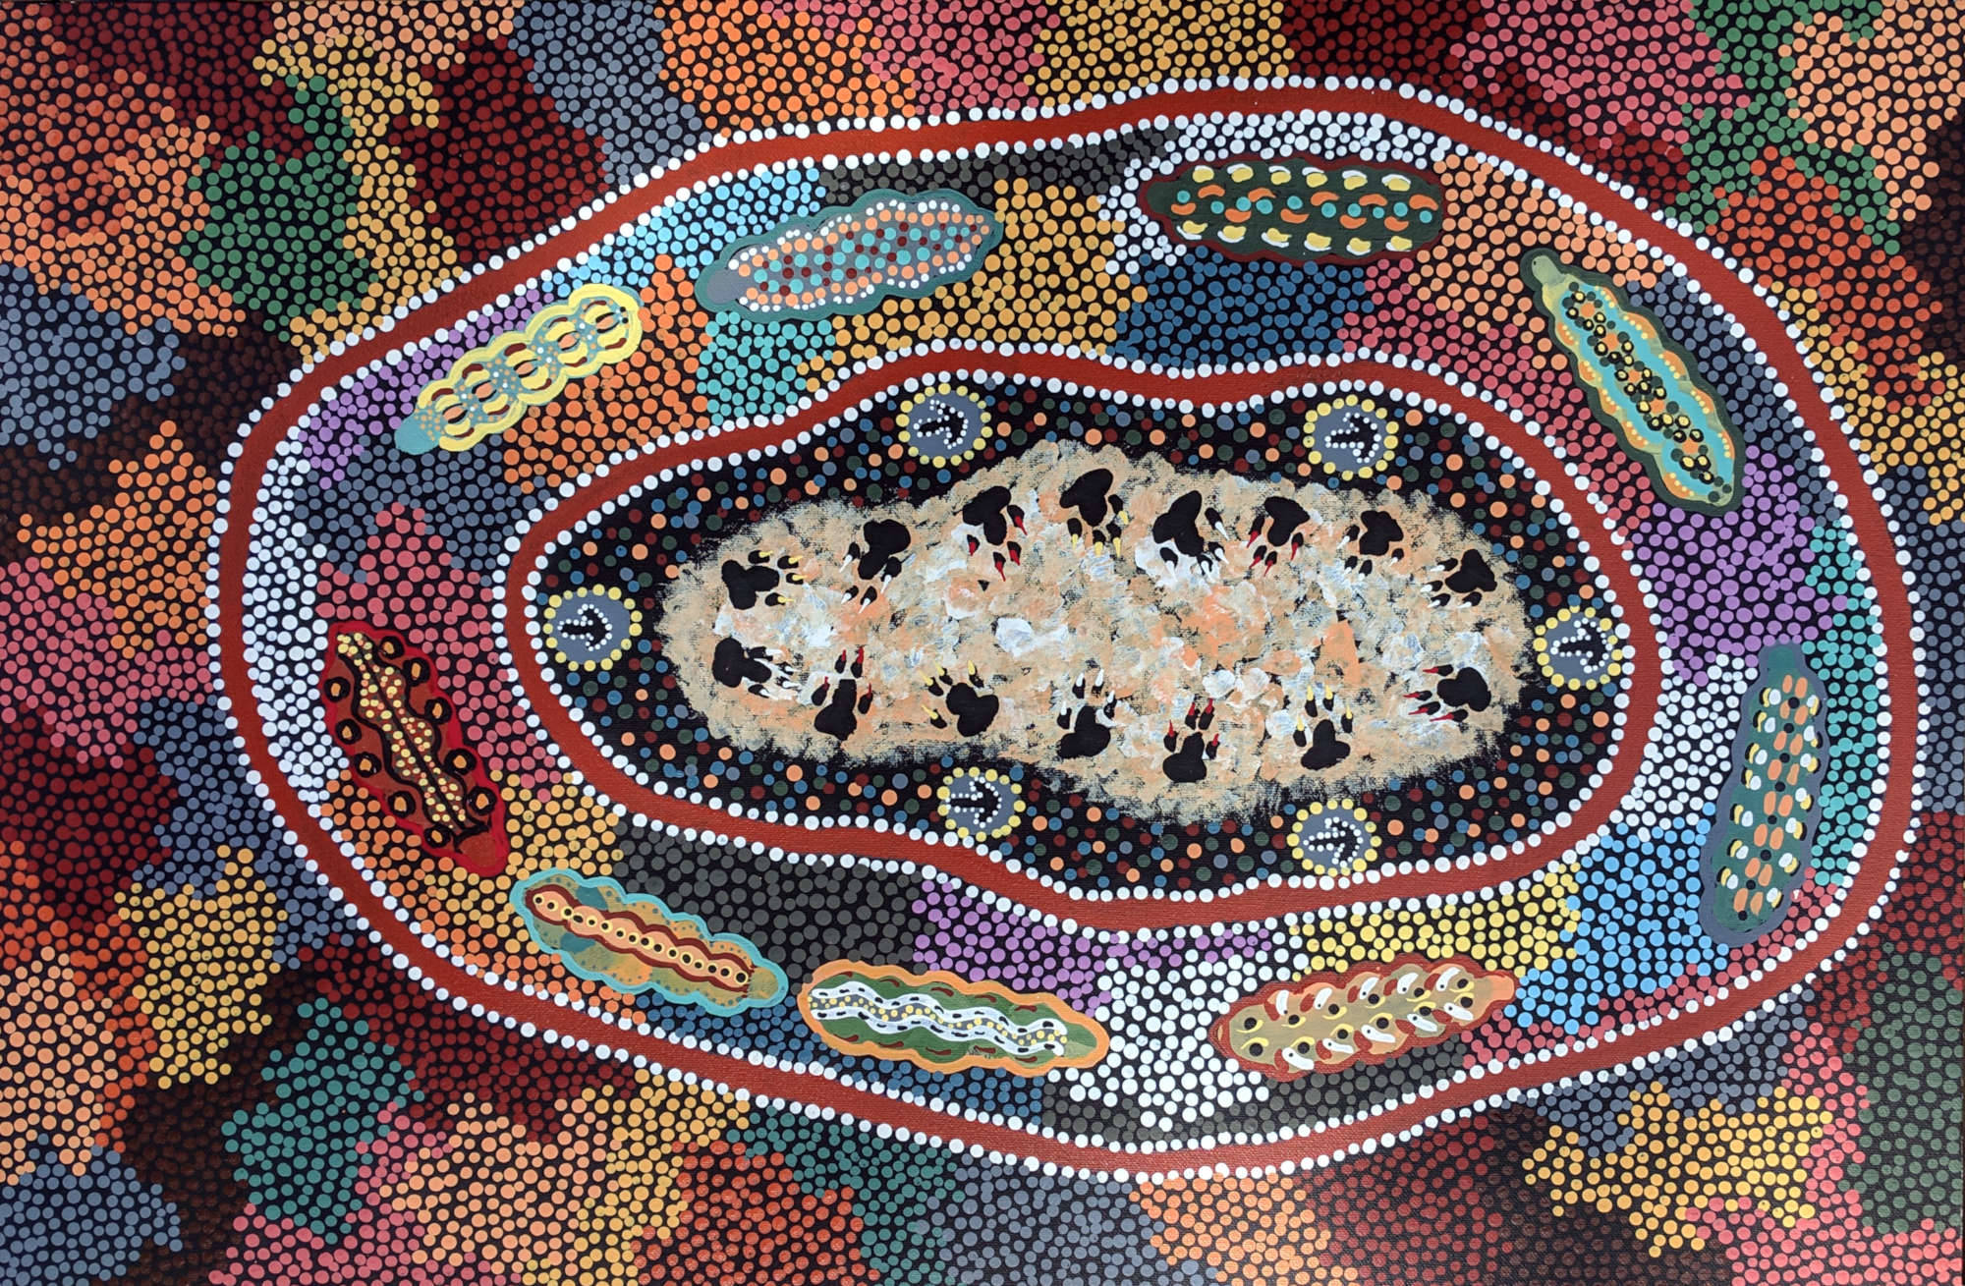
State how Aboriginal peoples’ verbal traditions successfully communicate knowledge across generations. Use an example to support your statement. (2 marks)
Knowledge is transferred through story (1)
Example (1/2 mark for statement, ½ mark for description)
_______________________________________________________________________________________________________________________________________________________________________________________________________________________________________________________________________________________________________________________________________________________________________________________

Question 19
- On the diagram below, correctly label the four seasons for the Southern Hemisphere.
1 mark for each correct season
(4 marks)
Autumn

Winter
Summer

Spring

- Do the Southern Hemisphere and Northern Hemisphere experience the same season at the same time? (1 mark)
No (1)

END OF TEST
Please go back and check your work / complete any unanswered questions.

